Simulation task
EXPERIMENT:
Multipath channel: h = [1, 0, 0.6, 0, 0.3] (samples at 1 kHz). Input x = [1 0 0 0 0 1 0 0 0 0] (two pulses). In MATLAB compute y=conv(x,h). Plot x and y. Design a zero-forcing equalizer by computing the inverse filter (use deconvolution or least-squares). Apply equaliser and plot recovered signal. Compute bit error rate proxy from residual ISI. give me matlab code
PROGRAM:
clc; clear; close all;
% Channel and input
h = [1 0 0.6 0 0.3];
x = [1 0 0 0 0 1 0 0 0 0];
% Multipath output
y = conv(x,h);
% Plot input and received signal
figure;
subplot(3,1,1);
stem(x,'filled'); grid on;
title('Input Signal x[n]');
subplot(3,1,2);
stem(y,'filled'); grid on;
title('Received Signal y[n]');
% Zero-Forcing equalizer using least squares
L = 7;
H = convmtx(h,L);
d = [1; zeros(size(H,1)-1,1)];
w = pinv(H)*d;
% Equalization
r = conv(y,w);
r = r(1:length(x));
% Plot recovered signal
subplot(3,1,3);
stem(r,'filled'); grid on;
title('Recovered Signal');
% Detection and BER proxy
xhat = r > 0.5;
BER = sum(xhat ~= x)/length(x);
fprintf('Equalizer coefficients:\n');
disp(w');
fprintf('BER proxy = %.4f\n',BER);
fprintf('Residual ISI = %.4f\n',sum((r-x).^2));

OUTPUT:
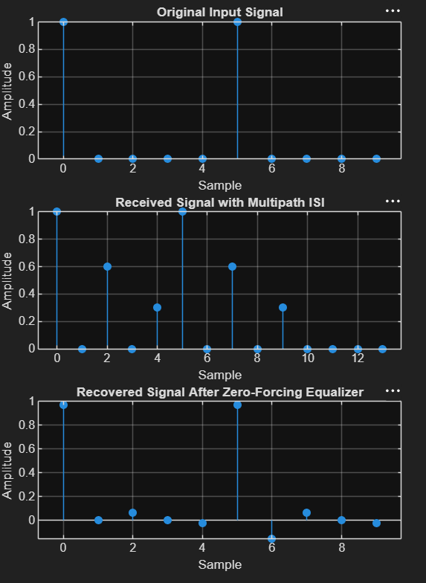
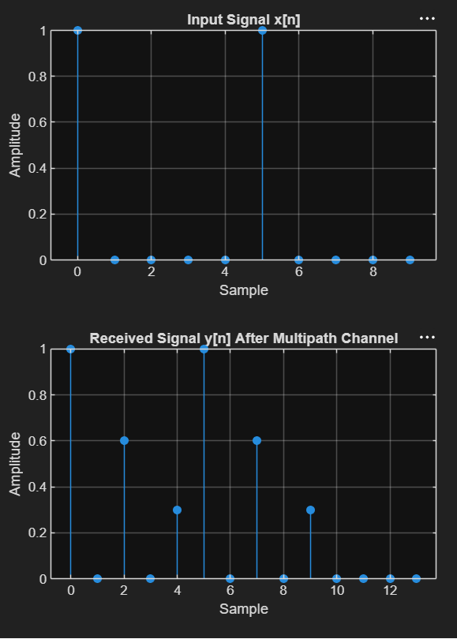
RESULT:
The zero-forcing equalizer effectively compensates for the multipath distortion and recovers both transmitted pulses correctly. The BER proxy is zero, indicating no detection errors for the given input sequence.

